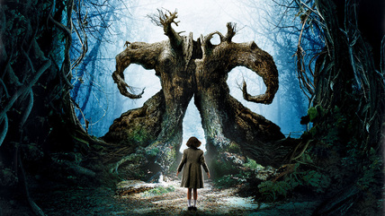
Movie Review
by
Don Huntley
Long ago in the Underground Realm, where there are no lies or pain, there lived a Princess who dreamt of the human world. She dreamt of blue skies, the soft breeze and sunshine. One day, eluding her keepers, the Princess escaped. Once outside the brightness blinded her and erased her memory She forgot who she was and where she came from. Her body suffered cold, sickness and pain. Eventually, she died. Her father always knew that the Princess would return, perhaps in another body, in another place, at another time. And he would wait for her, until he drew his last breath, until the world stopped turning.
So begins the tale of Ofelia, a precocious 11-year old girl, whose fertile imagination and love of fairy tales shapes the world in which she
lives. It is a brutal world gone mad, somehow made more bearable by her striking and sometimes disturbing imagination. The imaginal world is portrayed so seamlessly and naturally, that I hesitate to refer to as “imagination.” The movie, in fact, leads the viewer
into an understanding that her forays into this world are quite real.
Her story begins in 1944 as she and her ailing and pregnant mother, Carmen, travel by military caravan to meet Captain Vidal, Ofelia’s new stepfather and the father of Carmen’s unborn child. He is a brutal man. It is the aftermath of Spain’s Civil War and Captain Vidal is the ruthless leader of a remote military outpost, whose job is to quash the few remaining rebels living a sparse, but valiant existence in nearby woods.
In an opening scene that eerily foretells the movie’s unfold - ing, we see a small convoy of militarized Bentleys bounce over a rutted dirt road lined with ferns through a pristine, dew-draped forest. Carmen, Ofelia’s mother, brings the caravan to a halt with her urgent pleas to stop. She staggers from the car. nauseous. An odd scene follows, setting the overall magical tone of the movie: Ofelia sets off by herself, down the road, where she soon spots an eye-shaped stone lying in a rut. Upon grabbing the stone, an odd, flying, stick-like insect catches her attention, beckoning and leading her into the woods. There, she finds an old, weathered stone column with the ancient features of a face barely visible. Ofelia places the stone eye in its empty left socket. Immediately, a strange clicking noise emanates from the statue, and as if by magic, the stick-like insect emerges from the mouth.
“Ofelia??” her mother calls. Running back to the car, Ofelia cries out, “A fairy – I saw a fairy!” Ignoring the procla-mation, Carmen responds, “Oh look at your shoes! They’re covered with mud!” Captain Vidal watches as the caravan approaches the mill. Glancing at his cracked and emblematic golden pocket watch, Vidal remarks with cold exactness, “Fifteen minutes late.” It is his unborn—and
presumable—son that he is anxious for. Daughter and mother are peripheral to his desires.
Finally, at their destination: an old water mill set deep in the forest, Ofelia greets her new stepfather, the Captain. Clutch-ing her precious stack of fairy tale books in her right hand, she offers him her small, left hand. With his black, gloved hand, he grabs the child’s in a vice-like grip, and stares at her, coldly. “It’s the other hand, Ofelia.” Though fearful, the strong willed and independent Ofelia will not be cowed by his intimidation.
P an’s Labyrinth is an amazingly beautiful movie— though horrific at parts—it is an exquisite package: story, visuals, and music compel
the viewer to be entranced and sometimes repelled by this world. It is one of the most unusual movies I have ever seen. It was the recipient of six Oscar nominations including Art Direction, Cinematography, Foreign Language Film, Original Script, Makeup, and Musical Score. Of these, it won for Art Direction, Cinematography, and Makeup. The subdued and darkened lighting of most scenes reminded me of the old Dutch masters: Rubens or Rembrandt, where the light source was from a sin - gle, sunlit window or the soft, pale and diffused
natural light of the full moon. Never a hint of artificial light. For my eye, each scene was balanced, with characters and their setting presented with perfect visual tension.
It is the latest movie and vision by Mexican director Guillermo Del Toro. I learned in a recent Fresh Air interview with Terry Gross, that he is the heart and soul of this movie. From an early age, he was captivated by myth and fairy tales. He drew illustrations obsessively, with most being fanciful creatures or monsters. Many of his illustrations are used in The Book that Ofelia uses as her guide on her mythical quest. Not only did Del Toro conjure up and draw the creatures of the movie, but he also wrote the Oscar nominated script. While growing up, myth, fairy tales, and monsters were at his spiritual core. He said, “You know how some people accepted Jesus in their
heart? I was like that, but I accepted monsters in my heart!”
He grew up with Hell knocking at his door, thanks in part to his Grandmother, a woman obsessed with purity. He describes a time as a young boy when his Grandmother placed bottle caps, face up in his shoes to mortify the flesh. She instilled within him the fear of Hell and eternal dam-nation. Small wonder that his film before Pan’s Labyrinth was Hellboy, a story of a cigar chomping champion of good, who, though conceived in Hell to pursue evil ends, was rescued as an infant by a kindly doctor who taught him a better way. Del Toro
was twice exorcised by his Grandmother (not willingly of course). He describes the final exorcism at seventeen, when his Grandmother, fearful of his frightening drawings, sprinkled holy water on him while quoting exorcism rituals, all the while becoming more distressed as Guillermo laughed uncontrollably at the absurdity of it all. Now grown, he harbors no animosity towards her, but loves her for her unique
self.

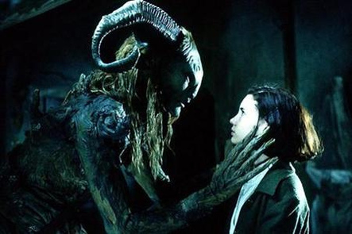
F earful of her new surroundings, Ofelia sleeps in the bed with her pregnant mother. Late one night, she awakens in the soft glow of a moonlit night to the clicking sound of the stick-insect. Silently, she shows the insect an illustration of a fairy from one of her books. Responding to the challenge, it transforms magically into a small bare-breasted fairy (but not Tinkerbell!). Acting as a messenger from the liminal world, the fairy beckons her word-lessly to follow. Outside now, Ofelia follows the fairy to an ancient and forgotten structure near the mill. Its labyrinthine path is overgrown with brush and knarled tree roots.
Downward leads a spiral staircase that opens to a Chartes Cathedral-like labyrinth. At its center, stands a stone monolith. Its power and presence is palpable. Out of the shadows steps a faun (termed “Pan” in the movie's English title). Ofelia backs away, speech-less. “Who are you?” she asks. He replies, “I’ve been called so many names that only the wind and the trees can pronounce. I am the mountain, the forest and the earth. I am… a faun.”
“You are Princess Moanna, daughter of the King of the underworld” he continues. “No, my father was a tailor,” she protests. He counters, “It was the moon that bore you. And your real father waits for your return, but first, we must be sure that you have not become mortal.” The faun gives her a book that will show her what must be done and charges her with three tasks to be completed so that the portal will open and allow her return to the Kingdom. The Book, the faun, and the fairies serve as her guides on this mythical quest.
Throughout the movie, the world of fairy tale is interwoven with the harsh outer world. When not ruthlessly pursuing the rebels, the Captain intimidates those around. In one particularly gruesome scene, he confronts two captured farmers, whose bad luck it is to be caught with game rifles while hunting rabbits. It is the only time, while watching the movie, that I had to cover my eyes. In another scene, the doctor tending to Carmen, ques-tions the Captain about his unreasoned assurance that the new-born will be a son. He replies chillingly, “Don’t fuck with me.”
The movie provides a window into Captain Vidal’s disturb-ing personality and inner life through his obsession with a gold pocket watch. He takes meticulous care of the watch in private, taking it apart, lubricating its gears, and adjusting it. This in odd contradiction to its cracked and flawed crystal face. At a dinner party with the mayor, the priest, and other local dignitaries, he is questioned about a rumored story that his father, in battle, cracked the watch so that his son would know the exact hour and minute of his death. Vidal denies the story. Secretly how-ever, the time-bound and negative father-possessed Vidal fingers the watch in his pocket.
Ofelia sets out to complete her first task. She must retrieve a golden key from a giant toad that is sucking the life force from an ancient fig tree. Dispensing with her dinner party dress, she crawls through a muck -filled cave under the tree’s roots. Certainly this is a place of the repressed feminine: the vagina-like entrance to the cave leads to a dark, wet and womb -like place. The toad she must confront is a common symbol of the feminine in fairy tales. And this one is especially big!
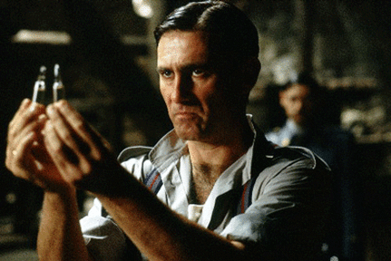
Meanwhile, above ground, the Captain’s dinner party continues. Town dignitaries are present and pay homage to the Captain. The dinner party is a mirror of the world that allows fascists regimes to take hold. The individual’s dignity and self expression are sacrificed on the alter of the stern father-state. Otherwise honorable town folk would never whisper a word of dissent. They are ordinary people, who become complicit as silent servants of a cultural conformity exacted by the brutal reality or war. They just nod their heads and say “okay.” Thankfully, people, such as the rebels and Ofelia, remain true to their inner nature, and Pan’s Labyrinth becomes a tale of salvation of the human spirit even in the face of ruthless suppression. Even in death, their spirits live.
For her second task, Ofelia must retrieve a dagger from an underground chamber. She is instructed to eat nothing that she sees. She walks softly down a long, columned corridor. She turns a corner and enters a large room. An enormous wooden table spans the room and is overflowing with every imaginable delicacy. At the head of the table, sits an odd, pale man. His head is eyeless, and his white skin hangs loosely in folds over his lanky frame. Her only task is to retrieve the dagger and eat nothing. Get the dagger and return. Simple. Understand? Right? Please, Ofelia don’t eat the fruit! Like Persephone, she does what she has been told not to do. Nearby is chest-high pile of children’s shoes—no doubt, victims of the pale man. Ghost cries of forlorn children echo though the halls. Dagger now in hand and task accomplished, she samples two, no, three grapes. The monster awakens. Uh oh!
This is a movie of opposites—the innocent girl-child is in opposition to the hardened and time bound masculine. The life bearing mother, Carmen, gives birth at the cost of her own. The militaristic arm of the Fascist state is frustrated by freedom loving rebels. Imagination against obedience and conformity. Strength against weakness. Innocence against evil. As the movie progresses, the boundaries between Ofelia’s imaginary world and the outer world blur and impinge on one another, until finally, opposites meet in the final climactic ending.
When I first saw this movie, I left, feeling a great sense of sadness, perhaps taking the ending a bit too literally. I left with my feet and heart still firmly planted in the dirt and blood of the old mill. My second viewing brought quite a different response. This time, I let go of the concrete reality and joined her in her underworld kingdom. I was one of the cheering crowds that celebrated her return. This time, I left with a smile ■
www.jungatlanta.com/articles/spring07-pans-labyrinth.pdf‎

