Name: _

Psycho Workbook

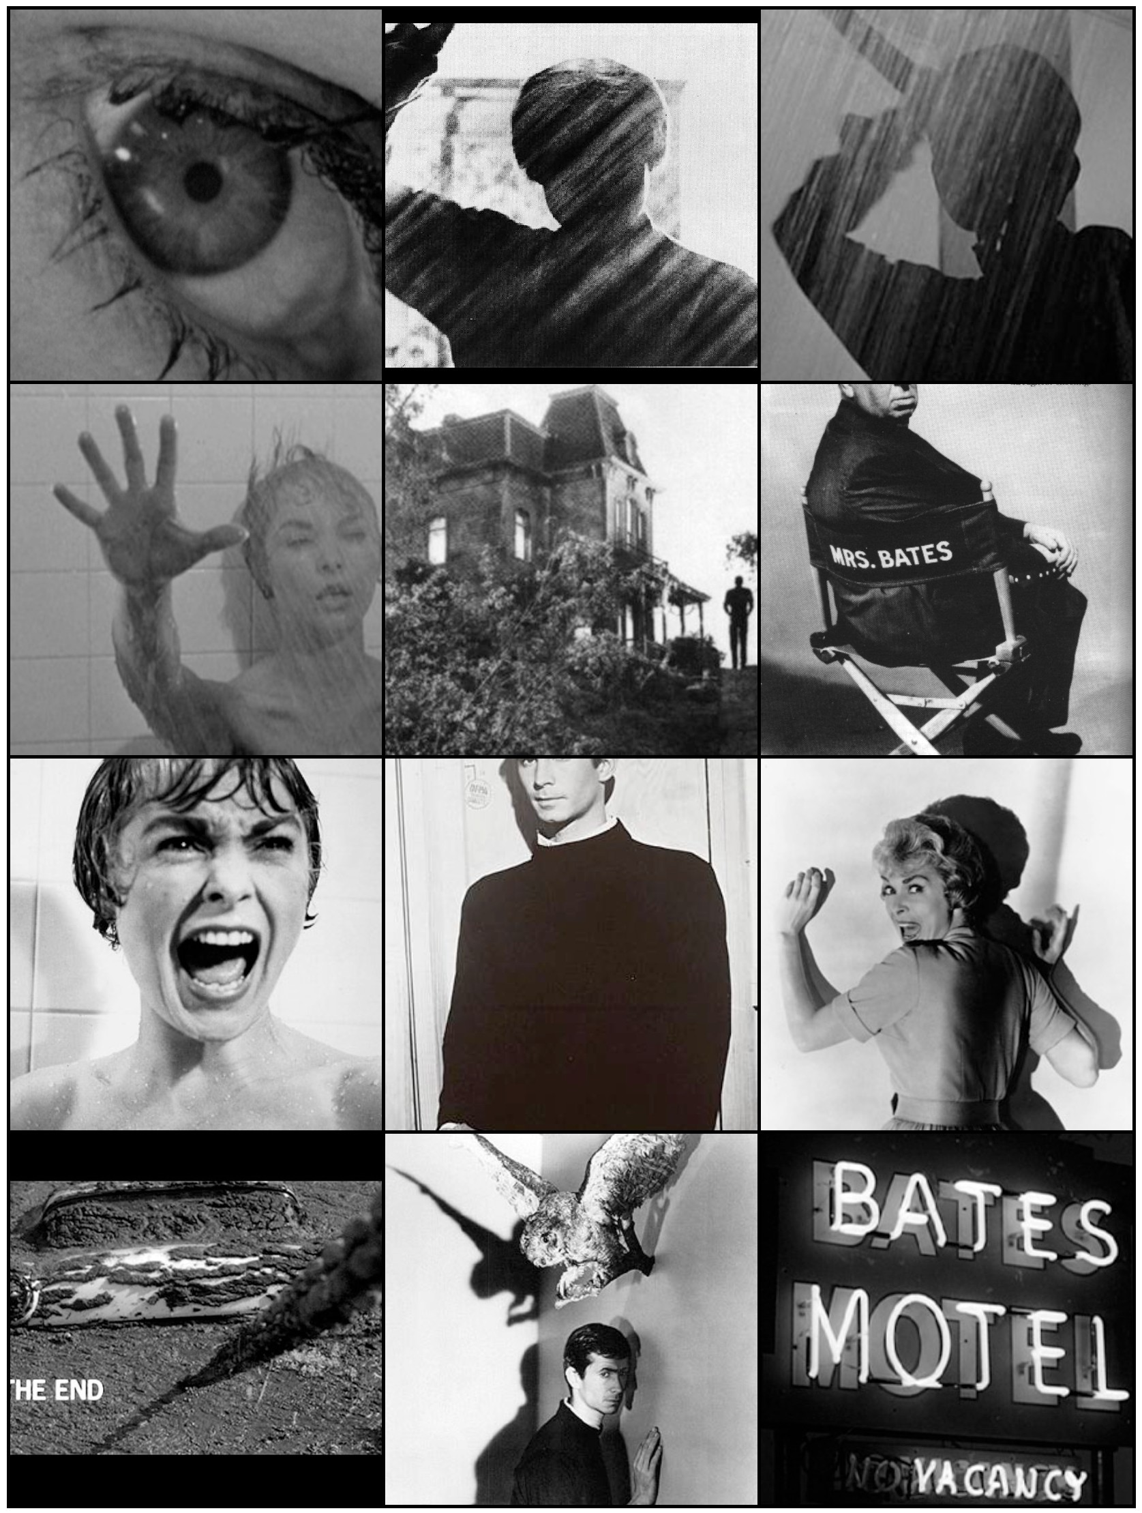

Tips for Responding to Questions

• Think carefully about what the question is asking you. Try to rephrase it in your own words.
• When you’re answering short answer questions such as these, try to provide a short overview of your answer in the very first sentence.
• The main part of your response should answer the question, making appropriate reference to the scene or
scenes you have been asked to write about.
• Use the language of film appropriately when you are answering questions.
• In the final paragraph of your answer, sum up briefly, giving a brief overview of what you have discussed, for example: “Throughout this scene, the director has used a range of techniques - such as acting, camera movement and sound - to develop the character.”

Production Elements (CAMELS)

Camera Techniques

Shot Size

• Establishing Shot/Extreme Long Shot. Establishing shots are often used at the beginning of scenes to establish the setting. At the beginning of a film, for example, you might see an extreme long shot of a city. Then, we might cut to a closer shot of a street, then a building and finally the character inside.
• Long Shot. A long shot is where you can see characters but the frame is largely filled with the background.
• Full Shot. A character filmed from head to toe.
• Mid Shot. A character filmed from the waist up.
• Close Up. Usually a shot of a character’s face.
• Extreme Close Up. Extreme close ups are usually an attempt to draw the viewer's attention to a particular detail.
For example, the director may choose to cut from a mid shot of a character to an extreme close-up of a gun in his hand.

Camera Angle

• Overshot. The camera is positioned directly above the subject. This is often used in establishing shots, where the camera flies over city streets..
• High Angle. The camera is positioned above the subject, looking down at an angle. This angle makes the subject appear smaller, powerless and more vulnerable.
• Eye Level. This is the most commonly used camera angle in film and television. The characters appear at eye level.
• Low Angle. The camera is positioned below eye level, looking up, to imply a sense of power and dominance.
• Undershot. The camera is positioned directly beneath the subject, looking up. Often coupled with point-of-view shots when the character is looking up at something.

Camera Movement

• Dolly. A dolly is any sort of moving platform that a camera is mounted on. Professional camera crews often lay down tracks which the camera can be moved along. Sometimes, the camera is mounted in the back of a car. Skateboards, office chairs and supermarket trolleys are the dollies of choice for low budget camera crews. Dollies are often used
in very subtle ways. Throughout the course of a conversation, for example, you may notice that the camera very slowly moves closer to the characters.
• Tracking Shot. Any sort of shot where the camera follows a moving subject.
• Pan. The camera turns horizontally when mounted on a tripod.
• Tilt. The camera tilts up/down when mounted on a tripod.
• Crane. The camera is mounted on a crane, helping filmmakers to achieve dynamic overhead shots.
• Handheld. Handheld camera movement is often used to achieve a sense of realism. Handheld camera movement achieves a sense of realism partly because audiences associate this sort of camera movement with documentary film.
• Steadicam. A device that allows camera operators to achieve smooth, fluid camera movement even when moving quickly across rough terrain.
• Zoom. The lens of a camera is used to magnify an image.

Acting

Acting also makes an important contribution to the narrative of films. While an extreme close up may show an actor’s face, it’s up to the actor to convey their emotions to the audience.

Mise-en-scene and Visual Composition

Visual composition refers to the way in which objects - such as props and actors - are arranged within the frame. Mise en scene is a French term that refers to 'putting into the scene'. Whereas visual composition usually refers to how specific elements are arranged, mise en scene is a broader term that refers to the artistic look and feel of a shot. It encompasses a range of elements, including lighting, costume, make up, camera techniques and the positioning and movement of actors.
Editing

Films are composed of shots which are edited together to tell a story.

• Cut The most basic edit. One shot is replaced by another. There is no transition between the two.

• Fade In. The screen is black, a shot gradually appears. Often used at the beginning of a sequence.

• Fade Out. An image gradually fades to black. This is often used at the end of a sequence.

Lighting

Lighting is often used to give the audience information about characters. For example, evil characters are traditionally shot with low key lighting to make them appear sinister. Low key lighting is often used to engage audiences, particularly in horror films.

• Key Light. The main source of light.

• Fill Light. A light which makes areas in shadow more visible.

• Back Light. A light source positioned behind the subject, often obscuring and creating a sense of menace.

• High Key. Few shadows and little contrast. Often used in television sitcoms. Uniform lighting allows scenes to be shot quickly without repositioning lights.

• Low Key. Creates a ‘chiaroscuro’ effect, a strong contrast between light and dark areas.

Sound and Music

Filmmakers think very carefully about the sound that they put in their films. Sound incorporates every aspect of the soundtrack - including sound effects, music and dialogue. Sound is always used to tell the story. Often sound effects can help tell us about the setting of a film. Music is one of the key techniques used to tell audiences how to feel. When watching films we are often encouraged to feel a sense of excitement or romance or adventure simply through the effective use of music.

Character Development in Psycho

When writing about how a character is established and developed, you can refer to a range of production elements, including: camera techniques, acting, mise-en-scene and visual composition, editing, lighting and sound (including music and dialogue).

1. How is Marion Crane established and developed as a character? Refer to the use of camera techniques, music, acting and dialogue (10 marks).

Point of View in Psycho
In film narratives, the audience is often encouraged to sympathize with particular characters, to see events from their point-of-view. As aspiring filmmakers, it is important to consider how Alfred Hitchcock encourages us to sympathize with particular characters.

Sample Response

M,"dway t'hroa3h t'he .f!IM, we are encoaro/jed t'o ,"den6/y' w,"t'h a nUMber ol' characterS,
,"nc./ad,""3 NorMan Eat'es. As Mar,"on leaves t'he par/oar, NorMan ret'arnS t'o ol'.f!ce and
/oo/:S ,"n t'he /ed3er. Cflt't'/n3 t'o an e)(t'reMe c/oSe-ap of' t'he reiSt'er, 'lf;t'chcocf: t'e//s t'he aad,"enc.e that' NorMan /:nowS Mar,"on has /,"ed a6oat' her naMe. Jast' as t'he aad,"enCe was
;Mp/,"cat'ed ;n t'he t'hel't' of' t'he .ff '}Q,QQQ, 'lf;t'chcocf: ;s prepar,"n3 t'o ;Mp/,"cat'e as ;n

NorMan's Cr,.Me. At t'h/s po,"nt' ;n t'he .f!IM, t'he aad,"enCe May /'eel Uneasy t'owards NorMan
3;ven t'he way h/s charac.t'er ,"s developed dar;n3 t'he par/oar SCene. As he CroSSeS t'he parlor, Anthony Perf:;ns ;s /,"'{' !'roM below, iV;n3 h<"M a 3hast'ly and bale/'a/ o/'.Pearanc.e.
5t'and,"n3 ;n l'ront' of' t'he pa,"n6n3s, h,"s l'ac.e ;s onCe o/ja!n b;Sect'ed 4; shadow, h/n6n:3 at'
h/S Sp/,"'{' perSonal,"t'y. #e hes,"t'at'eS f'or a MOMent' bef'ore /oof:;n3 t'owardS t'he pa,"nt'/n3, t'he wh,"t'es of' h,"s eyes 3/,"nt' Menac.;n3ly. >7'e hes,"t'at'es !'or a MOMent' bel'ore 'lf;t'chcocf: Cat'S t'o a c/oSe-ap of' t'he pa/nt'/":j aS he reMoVeS ,"'{' f'roM t'he wal/ t'o reVeal t'he peephole. Cat'6n3 bet'ween an ext'reMe close-ap of' NorMan's eye and a /'all shot' of' Mar,"on andreSS;n3, 'lf;t'chcocf: enCoilro/jeS t'he aad,"enCe t'o ,"den6f'y w,"t'h NorMan by
;Mpl,"ca6n3 t'heM ;n h,"s cr,"Me. Alt'hoa3h t'he aad,"enCe M)l have l'elt' aMb;Valent' t'owards

NorMan dar:n3 the par/oar sc
ene, th:.s po:nt-of-'v:ew shot enc2-oti/'C1je.S v:ewer.S to

,"dent'/f'y w,"t'h t'h,"s charac.t'er. 5,"M,"/ar/y, when he ret'arnS t'o t'he par/oar - o/',Propr,"at'e/y bat'hed ;n shadowS - t'he ext'reMe close-ap of' NorMan's eye and t'he v,"ew t'hroa3h t'he peep hole ;s a h•jhly voyear,"st'/c. One of' t'he ,"nt'ereS6n3 t'h,"n3s a6oat' Psycho ;s t'hat'
'lf;t'chcocf: enCoilro/jeS t'he aad,"enCe t'o ,"den6f'y w,"t'h t'he MUrderer, alt'hoa3h we don't
rea/:.se :t ant// the end of' the IJIM. When Ma.r:on Crane ;.:5 Mtlrdered, the aad:enc e 's

,"den6.f!ca6on ;s d,"rect'ed t'owards NorMan, t'he only ot'her charac.t'er ava!la6/e at' t'he 6Me.
7/,e br,"ef' po,"nt'-of'-v,"ew Shot'S ased t'hroa3hoat' t'h,"s SCene pave t'he way /'or t'h,"s sw,"t'ch ;n po,"nt'-of'-v,"ew. when NorMan ret'arnS t'o t'he hoaSe, 'lf;t'chcocf: ases v,"saal CoMpos,"t'/on t'o en3ender syMpathy /'or t'he charac.t'er. NorMan ;s .f!IMed s,"t't'/"3 alone ;n t'he f:;t'chen, perched on t'he ed3e of' a f:;t'chen cha;r. Shot' s,"ze and ac6n3 cont'r;bat'es t'o h/s SenSe of',"solat'/on. Alt'hoa3h he hasjast' broKen Mar,"on's t'rast', t'he aad,"enCe ;s encoaro/jed t'o v,"ew h/M ,"n a SyMPat'het'/c /,jht'. 'lf;t'chcocf: aSeS a ran3e of' t'ec.hn>fileS t'o
3et' as t'o syMpat'h,"se w,"t'h NorMan - ,"nclad,"n3 ed,"t',"n3, shot' s,"ze, CaMera t'echn>fileS, ac.6n3 and Soand.

2. At the beginning of the film, Hitchcock makes the audience identify and sympathise with Marion Crane. How does Hitchcock achieve this? Your response should make reference to camera techniques, acting, and sound. (10 marks)

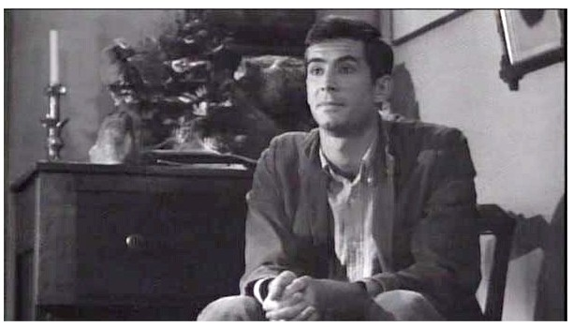Visual Composition in the Parlour Scene

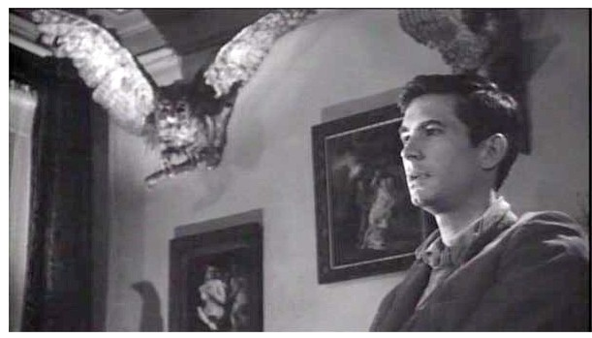In the parlour scene, Hitchcock uses mise-en-scene and visual composition to tell the audience a great deal about the characters.
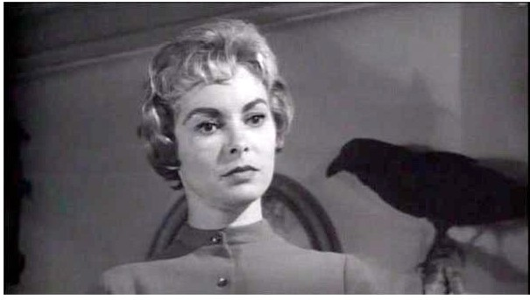

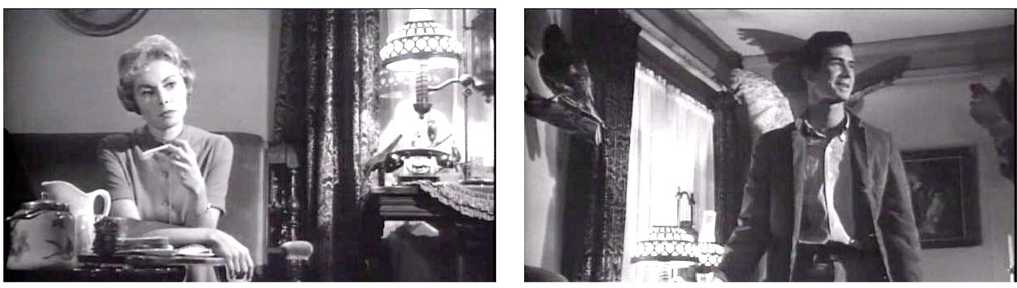

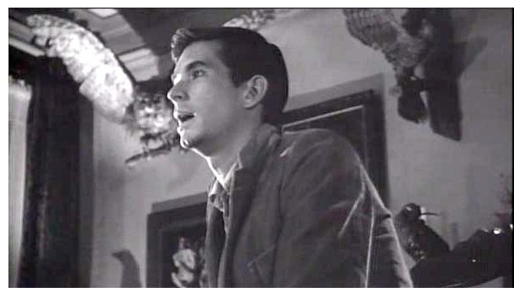

3. How is the audience positioned to feel about Norman throughout this scene? What do you make of the shadow that divide’s Norman’s face in half? What does the audience see around Norman throughout this scene? Compare these shots with the shots of Marion. How are they different? (10 marks)

Audience Engagement in the Psycho

Psycho has many example of how production elements (such as camera techniques, acting, mise-en-scene, editing, lighting and sound) can be used to engage audiences and create a sense of suspense.

Sample Response

When Marion flees Phoenix, Hitchcock uses a range of techniques to engage the audience. To begin with, Hitchcock shows a mid-shot of Marion sitting behind the wheel of her car. The audience hears her imagining what Sam will say when she arrives in Fairvale. The preceding scenes have strongly encouraged the audience to identify with Marion using a variety of production elements, chiefly camera techniques, editing, acting and music. Here, Hitchcock takes this one step further, using sound to convey her inner thoughts.

SAM (Voice Over): Marion, what in the world - what are you doing here? ...Of course I'm glad to see you. I always am. ...What is it, Marion?

Hearing a character’s thoughts like this is extremely engaging, encouraging the audience to see events from her perspective. As she is imagining what Sam will say, she
nervously adjusts her grip on the steering wheel and, pulls up at an intersection, resting her head on her hand. Hitchcock cuts from the mid-shot of Marion at the wheel of the car to a sustained point-of-view shot through the windshield. Several people pass
in front of the car. Hitchcock cuts back to Marion who still appears concerned. Cutting back to the point-of-view shot, Marion - and the audience - see Lowery and Cassidy pass in front of the car. As he passes, Lowery notices Marion and smiles politely. Hitchcock cuts to a mid-shot of Marion. Janet Leigh's acting contributes significantly to audience engagement. She smiles, clearly shocked. Hitchcock shows a point-of-view shot of Lowery as he turns and looks back at the car. He appears slightly puzzled. Herrmann's dramatic score begins suddenly. Deep and dramatic violins underscoring Lowery's discovery that Marion is leaving the city. Using a range of production elements - notably point-of-view shots - Hitchcock effectively engages the audience. Hitchcock cuts back to a close-up of Marion whose smile disappears. Audience engagement in this scene is particularly effective. Implicated in the crime, the audience desperately wants Marion to escape. Lowery turns away and continues walking. The audience is left with a sustained close-up of Marion as she continues to drive, face lined with apprehension.

4. Referring to a range of techniques - such as camera techniques, acting, mise-en-scene, editing, lighting and sound - explain how Hitchcock engages the audience when Arbogast is murdered (10 marks).

6. Referring to a range of techniques - such as camera techniques, acting, mise-en-scene, editing, lighting and sound - explain how Hitchcock engages the audience when Lila explores the Bates house. (10 marks)

